Feature Release Contact: Hailey Nelson
October 12, 2015 901-335-5597
FOR IMMEDIATE RELEASE hnelson6@vols.utk.edu

University of Tennessee Elects New SGA Leaders

KNOXVILLE, Tenn. 21-year-old Madison Kahl elected vice president of SGA at University of Tennessee Knoxville after prevalent work in the SGA office since her freshman year at UT. Kahl is known by her friends, family, and the rest of the student body at UT as a true “vol for life.”

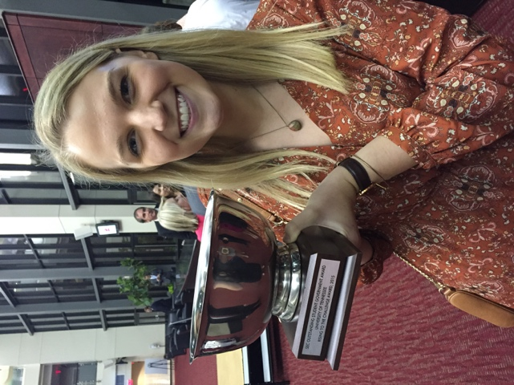

Born and raised in Knoxville, TN., Madison quickly realized after making 4.0’s in high school, all while simultaneously staying active in volunteer work and volleyball, she would definitely not stop making a difference in the Knoxville community anytime soon.

Kahl served on UT’s freshman council her freshman year, and served as a recruiter for the council the following two years. She then quickly applied to be an orientation leader her junior year, for the summer of 2015, and to no surprise, was given a position as an OL here at UT.

###
“I had such a great experience when I first came to the university. College can be scary and intimidating as a freshman, but my experience fell no where short of incredible. This university
truly is my home away from home and everyone deserves to have that same feeling when walking onto campus, whether it be for game day or a long night at Hodges.” says Kahl, after discussing her love for Knoxville and the University of Tennessee.

Kahl also is an active member of her sorority and held a position on the academic excellence committee her sophomore year. She was honored during this past fall recruitment by being chosen as one of two seniors in the entire senior pledge class to read a letter during preference round. Kahl’s heartfelt words spoke volumes to the potential new members and to the rest of the chapter. Chapter members say they will never forget the kind words Kahl had to say about all of her sisters, as well as the sound of the tears and sniffles that filled the room.

On top of making a huge and constant impact during her time here at the university, Kahl is also known for her kind and genuine heart. Her friends and sorority sisters have nothing but good things to say about her. “Madison is the type of girl to drop everything to go pick you up off the side of the road, or stay home with you on a Friday night because your boyfriend just broke up with you” Madison’s friend, Jessica Herbert, said.

Kahl can also be seen at every single leadership and service event at UT with a smile on her face. With hundreds of volunteer hours under her belt, Kahl is always seen going above and beyond to serve for her community. Teachers would even go to say that Madison is a natural born leader and it is nearly impossible for her to not leave an impression on her peers.

“College can be difficult even after being settled; and being the vice president of SGA here at UT can sometimes be a very difficult job. But with that being said, I will never stop doing my best to make this university the best it can be. It saw the potential in me, and I see the potential in it.” said Kahl, a true vol.

